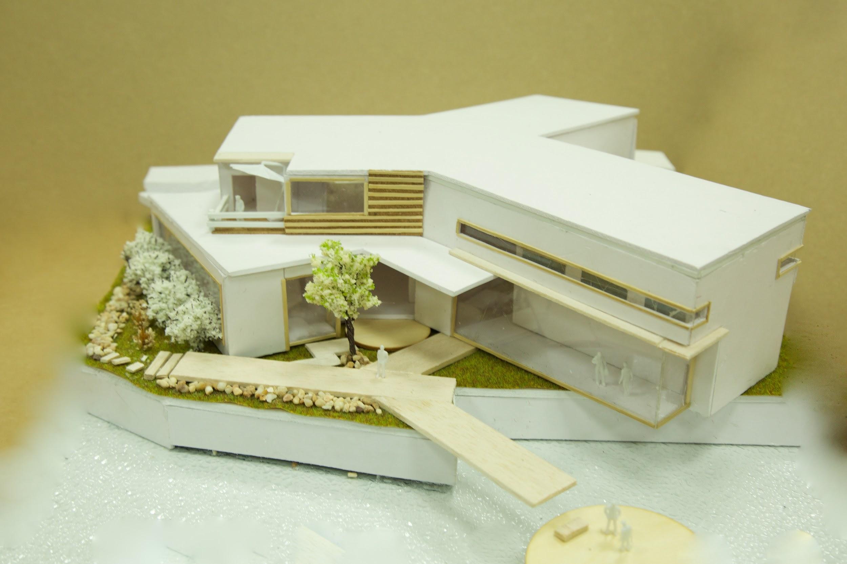

**About Me**

Hi, I’m Selene, a slash youth.

This is a collection of my work on STEAM learning. Yes, science, technology, engineering, art and mathematics will all be included! Btw, and I am also a Maker Educator. ;) 🥳